Algebra 2 Module 2 Topic 1: Relating Factors to Zeros

January 5th-12th: Topic 1 Lesson 1: Satisfactory Factoring: Factoring Polynomials to Identify Zeros
- Learn to factor higher level polynomials using:
  - GCF
  - Chunking
  - Grouping
  - Perfect Squares
  - Quadratic Form

January 12th-19th Topic 1 Lesson 2: Divide and Conquer: Polynomial Division
- Divide two polynomials
  - Polynomial Long Division
  - Test factors with synthetic division
  - Remainder Theorem
  - Factor Theorem

January 20th- Test Review
January 23rd Test covering Factoring polynomials and polynomial division

Standards: | Essential Questions:
- CCSS: HS.A-SSE.A.2 Use the structure of an expression to  identify ways to rewrite it.  - CCSS: HS.A-SSE.B.3  Choose and produce an equivalent form of an expression to reveal and explain properties of the quantity represented by the expression  - CCSS: HS.A-APR.B.3  Identify zeros of polynomials when suitable factorizations are available, and use the zeros to construct a rough graph of the function defined by the polynomial. | What is the relationship between factoring a polynomial and finding its zeros?  Why factor?  What information can you find from factored form?

Review from previous topics:

Quadratic Form | Example | Information from this form:
Standard Form:
Vertex Form:
Factored Form:

General Vocab:

Vocabulary | Definition | Example
Factor
Zeros
Greatest Common Factor (GCF)
Coefficient

Term

What you need to know and be able to do for Lesson 1: Satisfactory Factoring: Factoring Polynomials to Identify Zeros

When you have higher degree polynomials, you can find the zeros by factoring several ways:
Strategy | Steps:
Finding the GCF

Grouping

Chunking

,

Finding the Perfect Square Trinomial

Factoring using quadratic form

What you need to know and be able to do for Lesson 2: Divide and Conquer: Polynomial Division

Label the terms (quotient, divisor, dividend) for these equations:

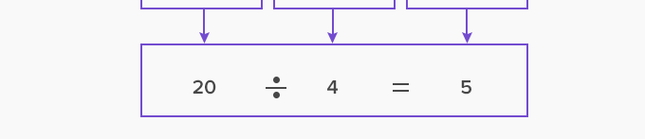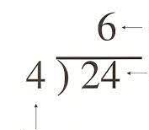

In a polynomial term, you treat it the same way:
p(x)=$x^{2}$-9x-10
q(x)= x+1
Divide p(x) by q(x)
$x^{2}$-9x-10 ÷ x+1 or X+1 ⟌$x^{2}$-9x-10

Solve. X+1 ⟌$x^{2}$-9x-10

Steps:

Synthetic Division:

Remainder Theorem:

Factor Theorem:

Practice/Extra Notes

